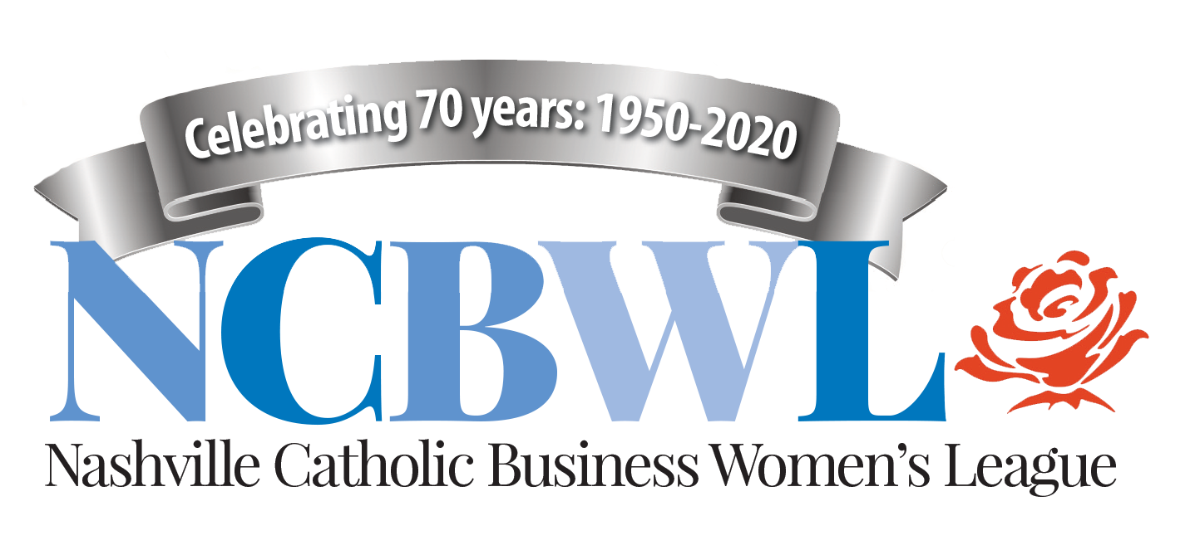

Dinner and Business
Meeting Agenda
Wednesday, January 18, 2023
Coco’s Italian Restaurant
411 51st Ave., Nashville, TN 37209
Living our Catholic faith through fellowship and service

5-6 p.m. Social Hour — Connect, mix and mingle
6 p.m. Welcome by Lynne Warne, President
New Members and Guests: Stand and introduce yourselves:
Our mission: To provide opportunities for Catholic women to engage in fellowship through stimulating programs and meaningful service.

Our vision: To connect, support and encourage Catholic women to live their faith.

FAITH: Let’s say grace together before we eat

6:10 p.m. Dinner and FELLOWSHIP: Enjoy each other’s company!

6:30 p.m. PROGRAM: Rosemary Plorin, President & CEO, Lovell Communications
The Inside Scoop: Leading a business built on leading with good news – and burying the bad

7 p.m. (or so) NCBWL Business Meeting

    - Upcoming meetings: February speaker: Donna Drehmann (customer experience expert and children’s book author); March speaker: Erin Va de Voorde (West of Perfection; discussion on handling mental/physical burnout); April meeting at CPC: Bi-Annual Membership meeting and new officer introduction

2) Social Action Update: Lisa Link

3) Status of 2023 Board of Directors Search: Claudia Weber

4) The “ask” — any business-related or spiritual requests? We want to support you!

5) Reflection and Closing prayer: Cheryl Pryor
26 attendees: 21 members, 4 guests
————————————————————————————————————————————
Follow us on Facebook and Instagram — and check out our website: www.ncbwl.org
Please sign up for Amazon Smiles and Kroger Care programs: Select NCBWL as your charity!

