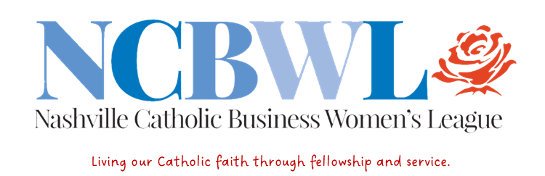

Dinner and Business Meeting Agenda
Wednesday September 20, 2023
Coco’s Italian Market Patio

5-6:00 PM Social Hour — Cash Bar available-credit cards accepted
A special tasting of Pumpkin Soup -provided by our speaker!

6:00 PM Welcome
Guests/New Members: introductions (name, parish, business).
Our mission: Providing opportunities for Catholic women to engage in fellowship through stimulating programs and meaningful service.

Saying Grace -Fr. John Sims Baker or Sr. Mary Peter Muehlenkamp

6:10 PM Dinner and conversation: Family style service including vegetarian option.
6:30 PM Reflection by Fr. John Sims-Baker

6:35 PM. PROGRAM: Catholic Medical Mission in Africa: Debbie Rayhab
Social Action: our donations to Catholic Medical Mission via our website
6:50 PM. NCBWL Business Meeting
- Committee reports: Treasurer Report -Karoline Mahoney; Membership-Ellen Wade; Communications-Patricia M. Smith. Social Media: Kelly Anne Colopietro

Programs-Mary Rolando Social Action: Carol Ann Fernandez
Hospitality- Tricia CasaSanta ; Parlimentarian: Connie Allison

- Old Business
Shopping event- results Kendra Scott 8/23/23
- New Business
New business- Lauren and Courtney Co -Chairs Pearls of Wisdom
update; need for volunteers and auction items.
The “ask” — any business-related, personal/spiritual requests?

7:30PM 7) Closing prayer and reflection on St. Mother Teresa-Jennie Guinn

Adjoun

————————————————————————————————————————————
Follow us on Facebook and Instagram — and visit our website: www.ncbwl.org
Please sign up for Kroger Cares Select NCBWL as your charity.

