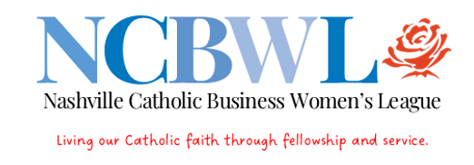
SURVEY OF NCWBL MEMBERS 2024

The purpose of this survey is to gain input from NCBWL members about League functions.

Please return response by April 1 to cweber@cctenn.org

For each element, circle YES/I agree, or NO/I do not agree.

- I attend most monthly membership meetings for fellowship/ business opportunities with other Catholic women. Y N

- RSVP process for monthly meetings is easy. Y N

Comments/suggestions about MEETINGS:

- Programs are informative and thought-provoking. Y N

- I would participate in/attend a Catholic Business Women business expo meeting. Y N

Comments/suggestions about PROGRAMS:

- Coco’s Italian Market is convenient; service and food are good. Y N

- I like the meetings at the schools recognizing scholarship recipients. Y N
Comments/suggestions about VENUE:

- Communiques (meeting notices, reminders, newsletters) are informative
and helpful. Y N

- The League website/member portal is easy to use. Y N

Comments/suggestions about COMMUNICATIONS:

- Dues and dinner prices are reasonable. Y N

Comments/suggestions about FINANCES:

- Ticket cost for Pearls of Wisdom Gala is reasonable Y N
- Country club venue for Gala is preferred. Y N
- Catholic Pastoral Center (Bishop’s Hall) preferred Y N

- I would work on the Gala committee. Y N

Comments/suggestions about the Pearls GALA:

- I appreciate receipt of birthday, sympathy, congratulatory cards and
follow-up notes to guests. Y N

Comments/Suggestions about HOSPITALITY:

Additional comments and suggestions which you would like to be considered by the Board and members:

Thank you for participating in this survey of NCBWL members.

Please return now to cweber@cctenn.org

By April 10. 2024

